**COVID-19 and Housing Comparison in Central Indiana**

**Purpose**

For our project, we wanted to incorporate real time data from a major, ongoing event, and apply that data at a local level. Our focus was then narrowed down to the impact of COVID on the local real estate market.

Questions asked in this project included:

1. Did COVID cases effect house prices in Marion and surrounding areas?
2. As number of cases went up did listings increase or decrease?
3. Did housing inventory decrease in the Indy Metro (in this study, referring to Boone, Hamilton, Hancock, Hendricks, Johnson, and Marion Counties) area over time in June-December 2020 as a result of the ongoing pandemic?

**Hypothesis**

Based on the nature of the pandemic, and the statistics of COVID released at the federal, state, and local levels, we would have predicted that COVID-19 would negatively impact the housing market, in particular the number of listings. That is, as COVID-19 cases rose, we would have expected the number of listings to decrease.

**Source Data References**

* COVID-19 data pulled from Indiana State Department of Health, <https://hub.mph.in.gov/dataset/covid-19-case-data>
* Housing Data pulled from Metropolitan Indianapolis Board of Realtors, <https://www.mibor.com/>

**Analysis**

COVID effects on Housing Prices

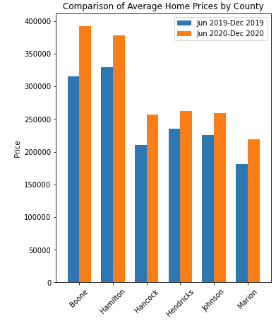 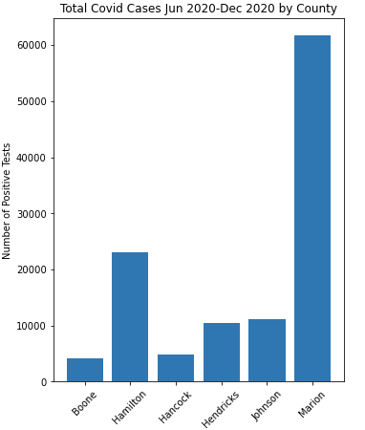

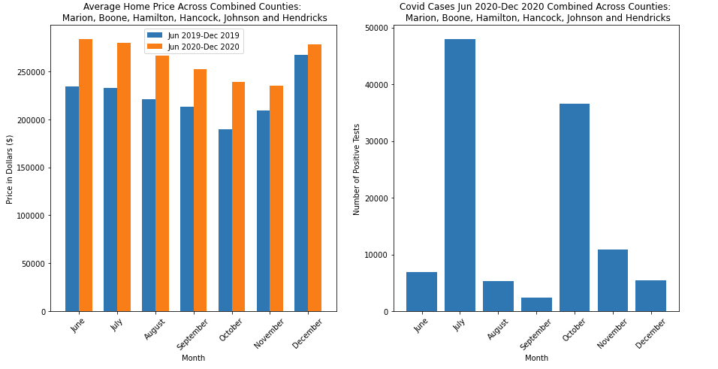

When looking at price of homes on a county-by-county basis, and comparing that to the number of COVID cases, there is no correlation.

To get a better overall representation, we analyzed the effect of average home prices in 2019 & 2020, compared to COVID cases over time in 2020, which also showed no correlation.

COVID effects on listings

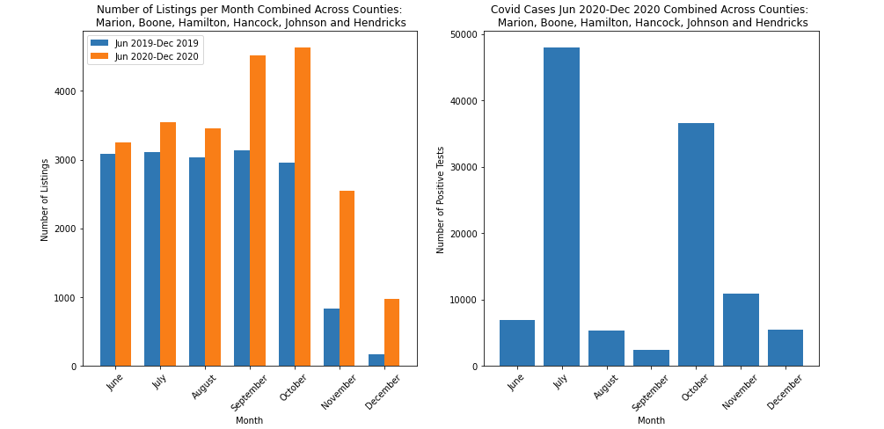

When analyzing this data, there appears to be some impact on the number of listings as seen by the large jumps in 2020 listings, most notably for months of September, October, and November. Although there is a noticeable increase in the number of listings for these months, further analysis on this question returned inconclusive results that COVID directly impacted the number of listings.

COVID effects on inventory

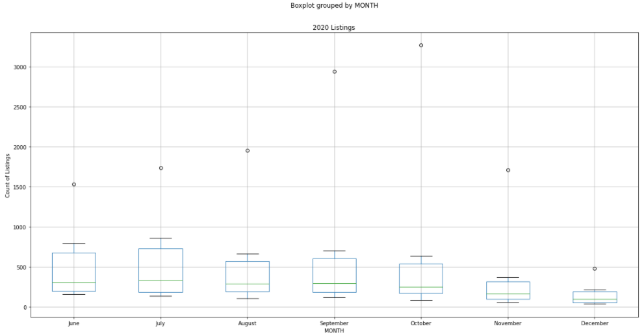

There is relatively little change in the boxplots from June – December 2020. This signals there is no impact of COVID on housing inventory. There are significant outliers in the dataset which could be impacting the data.

**Conclusion and Considerations**

After analyzing the data, we can safely conclude there is no significant impact of COVID on the Indianapolis Metro housing market. While some items, such as COVID and the number of listings seem related, there is inconclusive data to support the claim.

Some considerations to consider for the overall impact of this study:

* Economic impact of COVID, particularly around employment
* Rentals vs home sales
* COVID mandated moratorium on evictions & foreclosures
* Dedicated space for working from home due to workplace COVID restrictions
* Supply and demand of housing market
* COVID testing availability and accuracy